МИНИСТЕРСТВО НАУКИ И ВЫСШЕГО ОБРАЗОВАНИЯ РОССИЙСКОЙ ФЕДЕРАЦИИ

Федеральное государственное бюджетное образовательное учреждение

высшего образования

«**Вятский государственный университет**»

**(ФГБОУ ВО «ВятГУ»)**

Факультет автоматики и вычислительной техники

Кафедра ЭВМ

Отчёт

### Лабораторная работа № 3 по дисциплине

«Арифметико-логические основы вычислительной техники»

«Микропрограммное управление»

Выполнил студент группы ИВТб-1301 ________________/Жеребцов К. А.

## Проверил преподаватель ________________ /Коржавина А. С.

Киров 2021

***Цель:***

Выполнить умножение 4-мя способами в ПК, в ДК с РК, в ДК с АК.

***Задание:***

Необходимо создать микропрограммы для выполнения умножения.

***1 способ в ПК:***

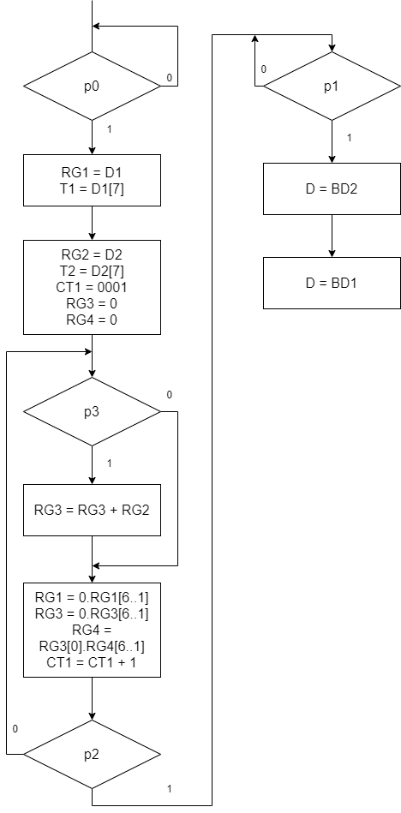

|  |  |  |  |  |  |  |  |  |  |  |  |  |  |  |
| --- | --- | --- | --- | --- | --- | --- | --- | --- | --- | --- | --- | --- | --- | --- |
|  | 13 | 12 | 11 | 10 | 9 | 8 | 7 | 6 | 5 | 4 | 3 | 2 | 1 | 0 |
| 1 | 0 | 0 | 0 | 0 | 0 | 0 | 0 | 0 | 0 | 0 | 0 | 0 | 0 | 1 |
| 2 | 0 | 0 | 0 | 1 | 0 | 0 | 0 | 0 | 0 | 1 | 0 | 0 | 0 | 0 |
| 3 | 0 | 0 | 1 | 0 | 0 | 0 | 1 | 1 | 0 | 0 | 0 | 1 | 0 | 0 |
| 4 | 0 | 0 | 0 | 0 | 0 | 1 | 0 | 0 | 0 | 0 | 0 | 0 | 0 | 0 |
| 5 | 0 | 0 | 0 | 0 | 1 | 0 | 0 | 0 | 1 | 0 | 1 | 0 | 0 | 0 |
| 6 | 0 | 0 | 0 | 0 | 0 | 0 | 0 | 0 | 0 | 0 | 0 | 0 | 1 | 0 |
| 7 | 0 | 1 | 0 | 0 | 0 | 0 | 0 | 0 | 0 | 0 | 0 | 0 | 0 | 0 |
| 8 | 1 | 0 | 0 | 0 | 0 | 0 | 0 | 0 | 0 | 0 | 0 | 0 | 0 | 0 |

|  |  |
| --- | --- |
|  | Код в 16 СС |
| 1 | 0001 |
| 2 | 0410 |
| 3 | 08с4 |
| 4 | 0100 |
| 5 | 0228 |
| 6 | 0002 |
| 7 | 2000 |
| 8 | 1000 |

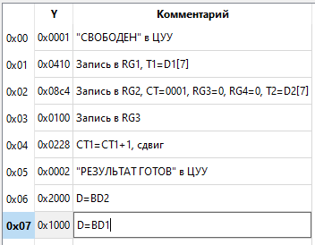

***2 способ в ПК:***

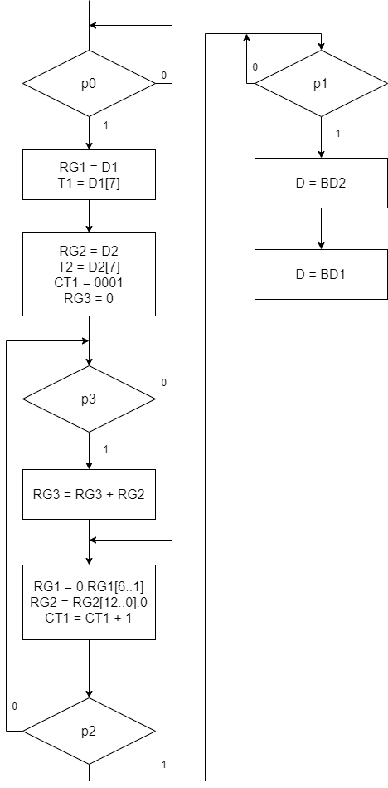

|  |  |  |  |  |  |  |  |  |  |  |  |  |  |  |
| --- | --- | --- | --- | --- | --- | --- | --- | --- | --- | --- | --- | --- | --- | --- |
|  | 13 | 12 | 11 | 10 | 9 | 8 | 7 | 6 | 5 | 4 | 3 | 2 | 1 | 0 |
| 1 | 0 | 0 | 0 | 0 | 0 | 0 | 0 | 0 | 0 | 0 | 0 | 0 | 0 | 1 |
| 2 | 0 | 0 | 0 | 1 | 0 | 0 | 0 | 0 | 0 | 1 | 0 | 0 | 0 | 0 |
| 3 | 0 | 0 | 1 | 0 | 0 | 1 | 0 | 1 | 0 | 0 | 0 | 1 | 0 | 0 |
| 4 | 0 | 0 | 0 | 0 | 1 | 0 | 0 | 0 | 0 | 0 | 0 | 0 | 0 | 0 |
| 5 | 0 | 0 | 0 | 0 | 0 | 0 | 1 | 0 | 1 | 0 | 1 | 0 | 0 | 0 |
| 6 | 0 | 0 | 0 | 0 | 0 | 0 | 0 | 0 | 0 | 0 | 0 | 0 | 1 | 0 |
| 7 | 1 | 0 | 0 | 0 | 0 | 0 | 0 | 0 | 0 | 0 | 0 | 0 | 0 | 0 |
| 8 | 0 | 1 | 0 | 0 | 0 | 0 | 0 | 0 | 0 | 0 | 0 | 0 | 0 | 0 |

|  |  |
| --- | --- |
|  | Код в 16 СС |
| 1 | 0001 |
| 2 | 0410 |
| 3 | 0944 |
| 4 | 0200 |
| 5 | 00A8 |
| 6 | 0002 |
| 7 | 2000 |
| 8 | 1000 |

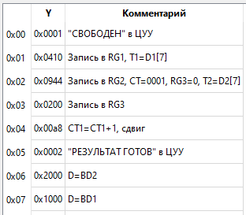

***3 способ в ПК:***

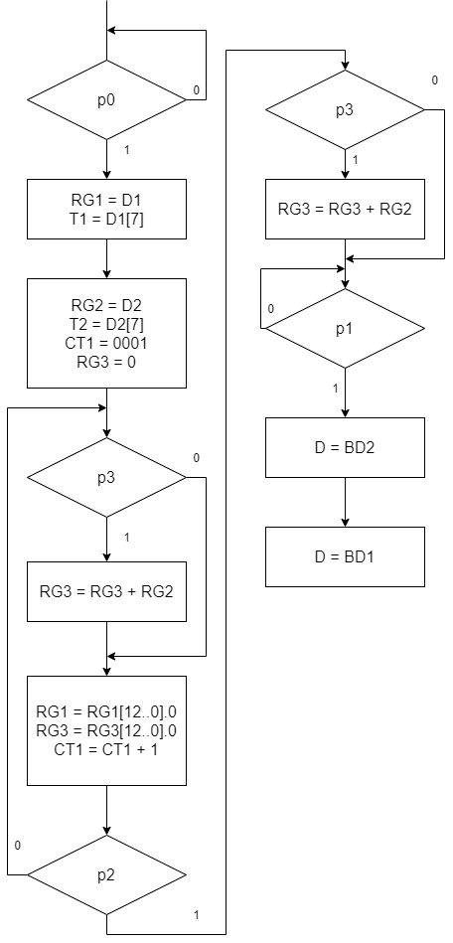

|  |  |  |  |  |  |  |  |  |  |  |  |  |  |  |
| --- | --- | --- | --- | --- | --- | --- | --- | --- | --- | --- | --- | --- | --- | --- |
|  | 13 | 12 | 11 | 10 | 9 | 8 | 7 | 6 | 5 | 4 | 3 | 2 | 1 | 0 |
| 1 | 0 | 0 | 0 | 0 | 0 | 0 | 0 | 0 | 0 | 0 | 0 | 0 | 0 | 1 |
| 2 | 0 | 0 | 0 | 1 | 0 | 0 | 0 | 0 | 0 | 1 | 0 | 0 | 0 | 0 |
| 3 | 0 | 0 | 1 | 0 | 0 | 0 | 1 | 1 | 0 | 0 | 0 | 1 | 0 | 0 |
| 4 | 0 | 0 | 0 | 0 | 0 | 1 | 0 | 0 | 0 | 0 | 0 | 0 | 0 | 0 |
| 5 | 0 | 0 | 0 | 0 | 1 | 0 | 0 | 0 | 1 | 0 | 1 | 0 | 0 | 0 |
| 6 | 0 | 0 | 0 | 0 | 0 | 0 | 0 | 0 | 0 | 0 | 0 | 0 | 1 | 0 |
| 7 | 1 | 0 | 0 | 0 | 0 | 0 | 0 | 0 | 0 | 0 | 0 | 0 | 0 | 0 |
| 8 | 0 | 1 | 0 | 0 | 0 | 0 | 0 | 0 | 0 | 0 | 0 | 0 | 0 | 0 |

|  |  |
| --- | --- |
|  | Код в 16 СС |
| 1 | 0001 |
| 2 | 0410 |
| 3 | 08с4 |
| 4 | 0100 |
| 5 | 0228 |
| 6 | 0002 |
| 7 | 2000 |
| 8 | 1000 |

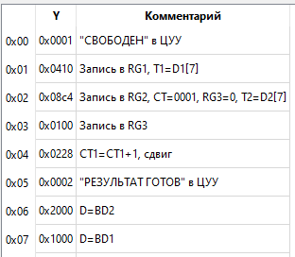

***4 способ в ПК:***

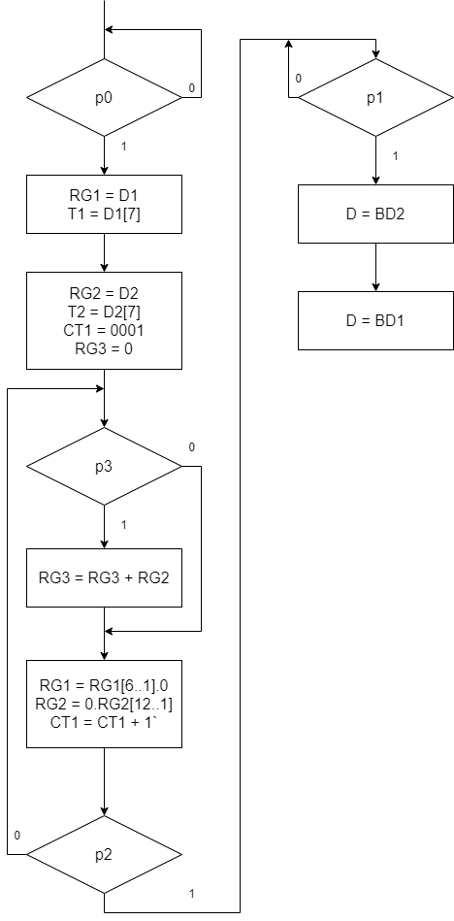

|  |  |  |  |  |  |  |  |  |  |  |  |  |  |  |
| --- | --- | --- | --- | --- | --- | --- | --- | --- | --- | --- | --- | --- | --- | --- |
|  | 13 | 12 | 11 | 10 | 9 | 8 | 7 | 6 | 5 | 4 | 3 | 2 | 1 | 0 |
| 1 | 0 | 0 | 0 | 0 | 0 | 0 | 0 | 0 | 0 | 0 | 0 | 0 | 0 | 1 |
| 2 | 0 | 0 | 0 | 1 | 0 | 0 | 0 | 0 | 0 | 1 | 0 | 0 | 0 | 0 |
| 3 | 0 | 0 | 1 | 0 | 0 | 1 | 0 | 1 | 0 | 0 | 0 | 1 | 0 | 0 |
| 4 | 0 | 0 | 0 | 0 | 1 | 0 | 0 | 0 | 0 | 0 | 0 | 0 | 0 | 0 |
| 5 | 0 | 0 | 0 | 0 | 0 | 0 | 1 | 0 | 1 | 0 | 1 | 0 | 0 | 0 |
| 6 | 0 | 0 | 0 | 0 | 0 | 0 | 0 | 0 | 0 | 0 | 0 | 0 | 1 | 0 |
| 7 | 1 | 0 | 0 | 0 | 0 | 0 | 0 | 0 | 0 | 0 | 0 | 0 | 0 | 0 |
| 8 | 0 | 1 | 0 | 0 | 0 | 0 | 0 | 0 | 0 | 0 | 0 | 0 | 0 | 0 |

|  |  |
| --- | --- |
|  | Код в 16 СС |
| 1 | 0001 |
| 2 | 0410 |
| 3 | 0944 |
| 4 | 0200 |
| 5 | 00A8 |
| 6 | 0002 |
| 7 | 2000 |
| 8 | 1000 |

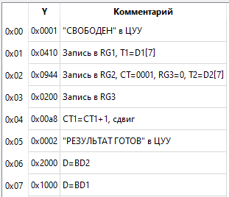

***1 способ в ДК с АК***

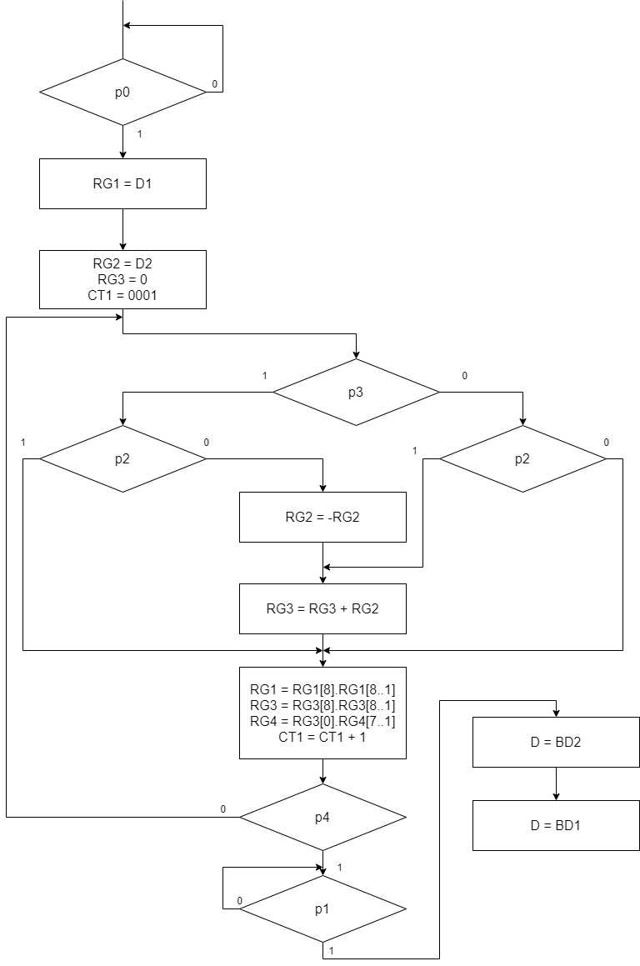

|  |  |  |  |  |  |  |  |  |  |  |  |  |  |
| --- | --- | --- | --- | --- | --- | --- | --- | --- | --- | --- | --- | --- | --- |
|  | 12 | 11 | 10 | 9 | 8 | 7 | 6 | 5 | 4 | 3 | 2 | 1 | 0 |
| 1 | 0 | 0 | 0 | 0 | 0 | 0 | 0 | 0 | 0 | 0 | 0 | 0 | 1 |
| 2 | 0 | 0 | 0 | 0 | 0 | 0 | 0 | 0 | 0 | 0 | 1 | 0 | 0 |
| 3 | 0 | 0 | 0 | 0 | 1 | 0 | 1 | 0 | 1 | 0 | 0 | 0 | 0 |
| 4(-) | 0 | 0 | 0 | 1 | 0 | 0 | 0 | 1 | 0 | 0 | 0 | 0 | 0 |
| 5(+) | 0 | 0 | 0 | 1 | 0 | 0 | 0 | 0 | 0 | 0 | 0 | 0 | 0 |
| 6 | 0 | 0 | 1 | 0 | 0 | 1 | 0 | 0 | 0 | 1 | 0 | 0 | 0 |
| 7 | 0 | 0 | 0 | 0 | 0 | 0 | 0 | 0 | 0 | 0 | 0 | 1 | 0 |
| 8 | 1 | 0 | 0 | 0 | 0 | 0 | 0 | 0 | 0 | 0 | 0 | 0 | 0 |
| 9 | 0 | 1 | 0 | 0 | 0 | 0 | 0 | 0 | 0 | 0 | 0 | 0 | 0 |

|  |  |
| --- | --- |
|  | Код в 16 СС |
| 1 | 0001 |
| 2 | 0004 |
| 3 | 0150 |
| 4 | 0220 |
| 5 | 0200 |
| 6 | 0488 |
| 7 | 0002 |
| 8 | 1000 |
| 9 | 0800 |

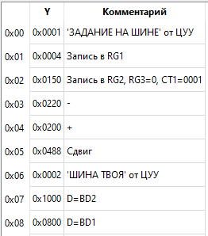

***2 способ в ДК с АК:***

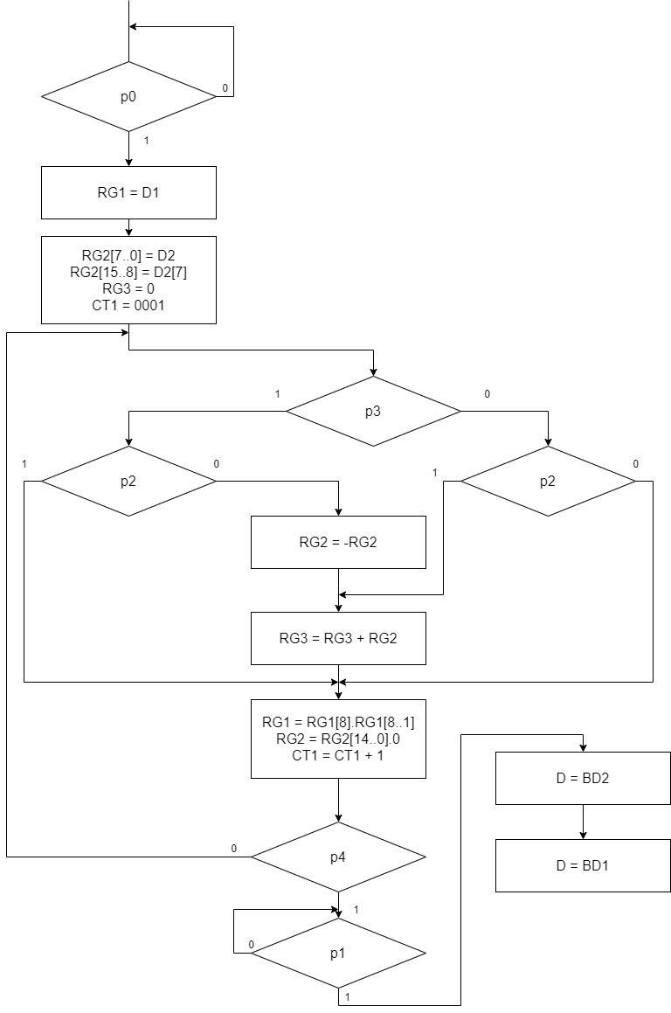

|  |  |  |  |  |  |  |  |  |  |  |  |  |  |
| --- | --- | --- | --- | --- | --- | --- | --- | --- | --- | --- | --- | --- | --- |
|  | 12 | 11 | 10 | 9 | 8 | 7 | 6 | 5 | 4 | 3 | 2 | 1 | 0 |
| 1 | 0 | 0 | 0 | 0 | 0 | 0 | 0 | 0 | 0 | 0 | 0 | 0 | 1 |
| 2 | 0 | 0 | 0 | 0 | 0 | 0 | 0 | 0 | 0 | 0 | 1 | 0 | 0 |
| 3 | 0 | 0 | 0 | 1 | 0 | 1 | 0 | 0 | 1 | 0 | 0 | 0 | 0 |
| 4(-) | 0 | 0 | 1 | 0 | 0 | 0 | 1 | 0 | 0 | 0 | 0 | 0 | 0 |
| 5(+) | 0 | 0 | 1 | 0 | 0 | 0 | 0 | 0 | 0 | 0 | 0 | 0 | 0 |
| 6 | 0 | 0 | 0 | 0 | 1 | 0 | 0 | 1 | 0 | 1 | 0 | 0 | 0 |
| 7 | 0 | 0 | 0 | 0 | 0 | 0 | 0 | 0 | 0 | 0 | 0 | 1 | 0 |
| 8 | 1 | 0 | 0 | 0 | 0 | 0 | 0 | 0 | 0 | 0 | 0 | 0 | 0 |
| 9 | 0 | 1 | 0 | 0 | 0 | 0 | 0 | 0 | 0 | 0 | 0 | 0 | 0 |

|  |  |
| --- | --- |
|  | Код в 16 СС |
| 1 | 0001 |
| 2 | 0004 |
| 3 | 0290 |
| 4 | 0440 |
| 5 | 0400 |
| 6 | 0128 |
| 7 | 0002 |
| 8 | 1000 |
| 9 | 0800 |

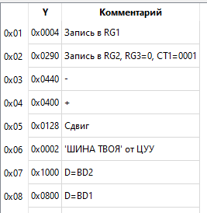

***3 способ в ДК с АК:***

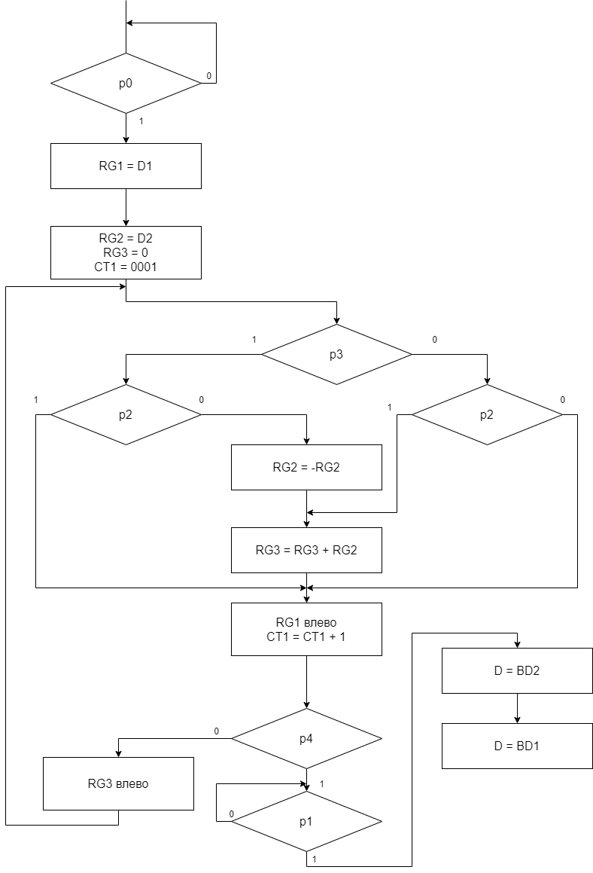

|  |  |  |  |  |  |  |  |  |  |  |  |  |  |
| --- | --- | --- | --- | --- | --- | --- | --- | --- | --- | --- | --- | --- | --- |
|  | 12 | 11 | 10 | 9 | 8 | 7 | 6 | 5 | 4 | 3 | 2 | 1 | 0 |
| 1 | 0 | 0 | 0 | 0 | 0 | 0 | 0 | 0 | 0 | 0 | 0 | 0 | 1 |
| 2 | 0 | 0 | 0 | 0 | 0 | 0 | 0 | 0 | 0 | 0 | 1 | 0 | 0 |
| 3 | 0 | 0 | 0 | 0 | 1 | 0 | 1 | 0 | 1 | 0 | 0 | 0 | 0 |
| 4(-) | 0 | 0 | 0 | 1 | 0 | 0 | 0 | 1 | 0 | 0 | 0 | 0 | 0 |
| 5(+) | 0 | 0 | 0 | 1 | 0 | 0 | 0 | 0 | 0 | 0 | 0 | 0 | 0 |
| 6 | 0 | 0 | 0 | 0 | 0 | 1 | 0 | 0 | 0 | 1 | 0 | 0 | 0 |
| 7 | 0 | 0 | 0 | 0 | 0 | 0 | 0 | 0 | 0 | 0 | 0 | 1 | 0 |
| 8 | 1 | 0 | 0 | 0 | 0 | 0 | 0 | 0 | 0 | 0 | 0 | 0 | 0 |
| 9 | 0 | 1 | 0 | 0 | 0 | 0 | 0 | 0 | 0 | 0 | 0 | 0 | 0 |
| 10 | 0 | 0 | 1 | 0 | 0 | 0 | 0 | 0 | 0 | 0 | 0 | 0 | 0 |

|  |  |
| --- | --- |
|  | Код в 16 СС |
| 1 | 0001 |
| 2 | 0004 |
| 3 | 0150 |
| 4 | 0220 |
| 5 | 0200 |
| 6 | 0088 |
| 7 | 0002 |
| 8 | 1000 |
| 9 | 0800 |
| 10 | 0400 |

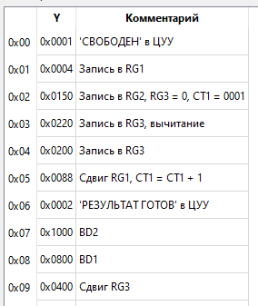

***4 способ в ДК с АК:***

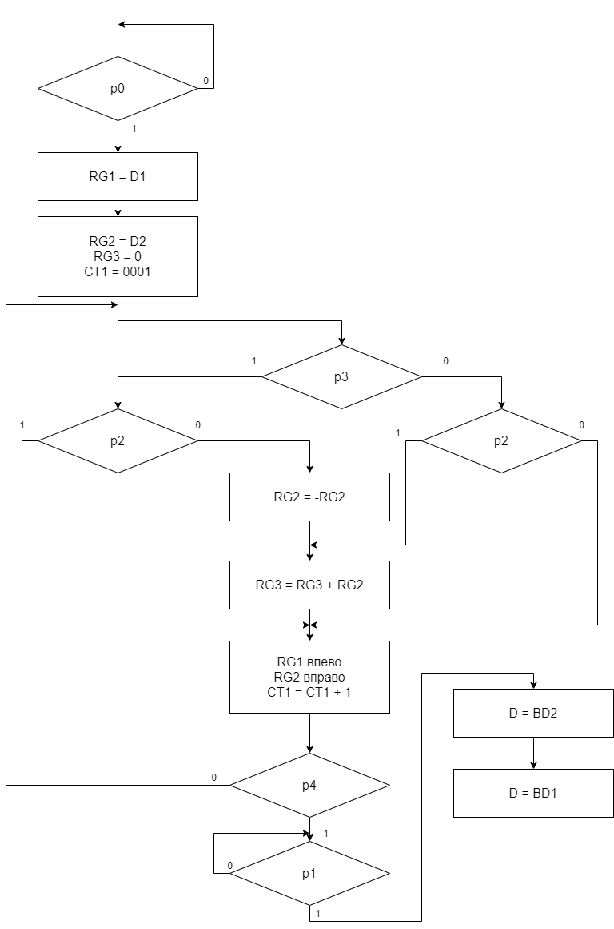

|  |  |  |  |  |  |  |  |  |  |  |  |  |  |
| --- | --- | --- | --- | --- | --- | --- | --- | --- | --- | --- | --- | --- | --- |
|  | 12 | 11 | 10 | 9 | 8 | 7 | 6 | 5 | 4 | 3 | 2 | 1 | 0 |
| 1 | 0 | 0 | 0 | 0 | 0 | 0 | 0 | 0 | 0 | 0 | 0 | 0 | 1 |
| 2 | 0 | 0 | 0 | 0 | 0 | 0 | 0 | 0 | 0 | 0 | 1 | 0 | 0 |
| 3 | 0 | 0 | 0 | 1 | 0 | 1 | 0 | 0 | 1 | 0 | 0 | 0 | 0 |
| 4(-) | 0 | 0 | 1 | 0 | 0 | 0 | 1 | 0 | 0 | 0 | 0 | 0 | 0 |
| 5(+) | 0 | 0 | 1 | 0 | 0 | 0 | 0 | 0 | 0 | 0 | 0 | 0 | 0 |
| 6 | 0 | 0 | 0 | 0 | 1 | 0 | 0 | 1 | 0 | 1 | 0 | 0 | 0 |
| 7 | 0 | 0 | 0 | 0 | 0 | 0 | 0 | 0 | 0 | 0 | 0 | 1 | 0 |
| 8 | 1 | 0 | 0 | 0 | 0 | 0 | 0 | 0 | 0 | 0 | 0 | 0 | 0 |
| 9 | 0 | 1 | 0 | 0 | 0 | 0 | 0 | 0 | 0 | 0 | 0 | 0 | 0 |

|  |  |
| --- | --- |
|  | Код в 16 СС |
| 1 | 0001 |
| 2 | 0004 |
| 3 | 0290 |
| 4 | 0440 |
| 5 | 0400 |
| 6 | 0128 |
| 7 | 0002 |
| 8 | 1000 |
| 9 | 0800 |

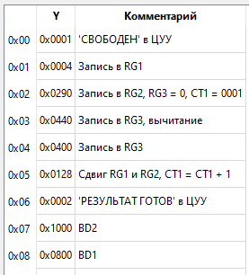

***1 способ в ДК с РК:***

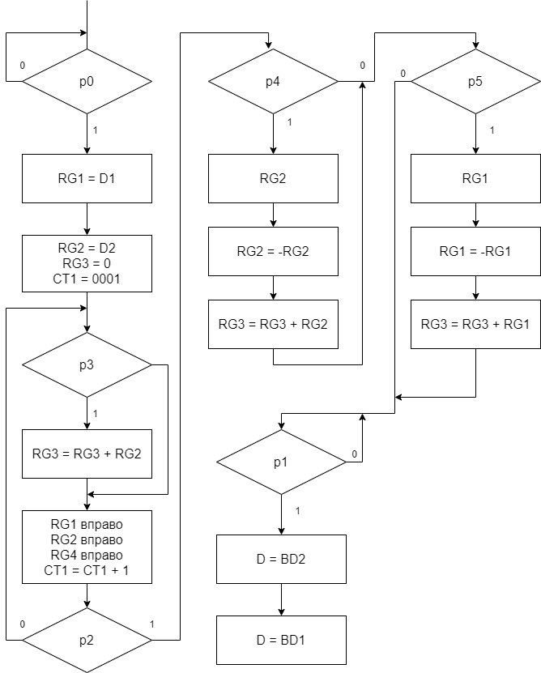

|  |  |  |  |  |  |  |  |  |  |  |  |  |  |  |
| --- | --- | --- | --- | --- | --- | --- | --- | --- | --- | --- | --- | --- | --- | --- |
|  | 13 | 12 | 11 | 10 | 9 | 8 | 7 | 6 | 5 | 4 | 3 | 2 | 1 | 0 |
| 1 | 0 | 0 | 0 | 0 | 0 | 0 | 0 | 0 | 0 | 0 | 0 | 0 | 0 | 1 |
| 2 | 0 | 0 | 0 | 0 | 0 | 0 | 0 | 0 | 0 | 1 | 0 | 0 | 0 | 0 |
| 3 | 0 | 0 | 0 | 0 | 0 | 0 | 1 | 1 | 0 | 0 | 0 | 1 | 0 | 0 |
| 4 | 0 | 0 | 0 | 0 | 0 | 1 | 0 | 0 | 0 | 0 | 0 | 0 | 0 | 0 |
| 5 | 0 | 0 | 0 | 0 | 1 | 0 | 0 | 0 | 1 | 0 | 1 | 0 | 0 | 0 |
| 6 | 0 | 0 | 1 | 0 | 0 | 1 | 0 | 0 | 0 | 0 | 0 | 0 | 0 | 0 |
| 7 | 0 | 0 | 1 | 1 | 0 | 1 | 0 | 0 | 0 | 0 | 0 | 0 | 0 | 0 |
| 8 | 0 | 0 | 0 | 0 | 0 | 0 | 0 | 0 | 0 | 0 | 0 | 0 | 1 | 0 |
| 9 | 1 | 0 | 0 | 0 | 0 | 0 | 0 | 0 | 0 | 0 | 0 | 0 | 0 | 0 |
| 10 | 0 | 1 | 0 | 0 | 0 | 0 | 0 | 0 | 0 | 0 | 0 | 0 | 0 | 0 |

|  |  |
| --- | --- |
|  | Код в 16 СС |
| 1 | 0001 |
| 2 | 0010 |
| 3 | 00с4 |
| 4 | 0100 |
| 5 | 0228 |
| 6 | 0900 |
| 7 | 0d00 |
| 8 | 0002 |
| 9 | 2000 |
| 10 | 1000 |

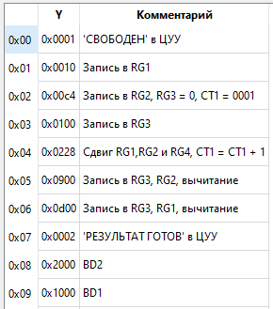

***2 способ в ДК с РК:***

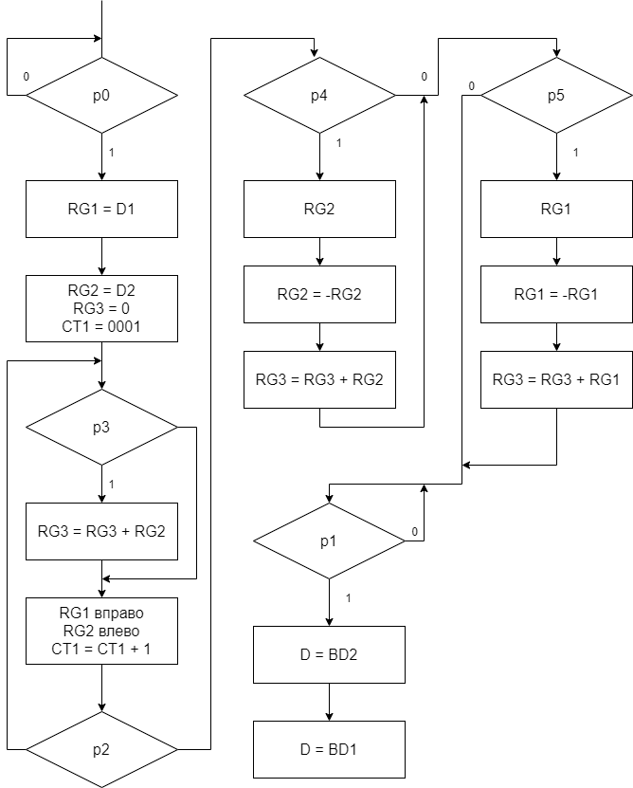

|  |  |  |  |  |  |  |  |  |  |  |  |  |  |  |
| --- | --- | --- | --- | --- | --- | --- | --- | --- | --- | --- | --- | --- | --- | --- |
|  | 13 | 12 | 11 | 10 | 9 | 8 | 7 | 6 | 5 | 4 | 3 | 2 | 1 | 0 |
| 1 | 0 | 0 | 0 | 0 | 0 | 0 | 0 | 0 | 0 | 0 | 0 | 0 | 0 | 1 |
| 2 | 0 | 0 | 0 | 0 | 0 | 0 | 0 | 0 | 0 | 0 | 0 | 1 | 0 | 0 |
| 3 | 0 | 0 | 0 | 0 | 1 | 0 | 0 | 1 | 0 | 1 | 0 | 0 | 0 | 0 |
| 4 | 0 | 0 | 0 | 0 | 0 | 0 | 1 | 0 | 0 | 0 | 0 | 0 | 0 | 0 |
| 5 | 0 | 0 | 0 | 1 | 0 | 0 | 0 | 0 | 1 | 0 | 1 | 0 | 0 | 0 |
| 6 | 0 | 0 | 1 | 0 | 0 | 0 | 1 | 0 | 0 | 0 | 0 | 0 | 0 | 0 |
| 7 | 0 | 0 | 1 | 0 | 0 | 1 | 1 | 0 | 0 | 0 | 0 | 0 | 0 | 0 |
| 8 | 0 | 0 | 0 | 0 | 0 | 0 | 0 | 0 | 0 | 0 | 0 | 0 | 1 | 0 |
| 9 | 1 | 0 | 0 | 0 | 0 | 0 | 0 | 0 | 0 | 0 | 0 | 0 | 0 | 0 |
| 10 | 0 | 1 | 0 | 0 | 0 | 0 | 0 | 0 | 0 | 0 | 0 | 0 | 0 | 0 |

|  |  |
| --- | --- |
|  | Код в 16 СС |
| 1 | 0001 |
| 2 | 0004 |
| 3 | 0250 |
| 4 | 0080 |
| 5 | 0428 |
| 6 | 0880 |
| 7 | 0980 |
| 8 | 0002 |
| 9 | 2000 |
| 10 | 1000 |

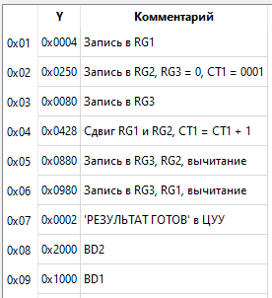

***3 способ в ДК с РК:***

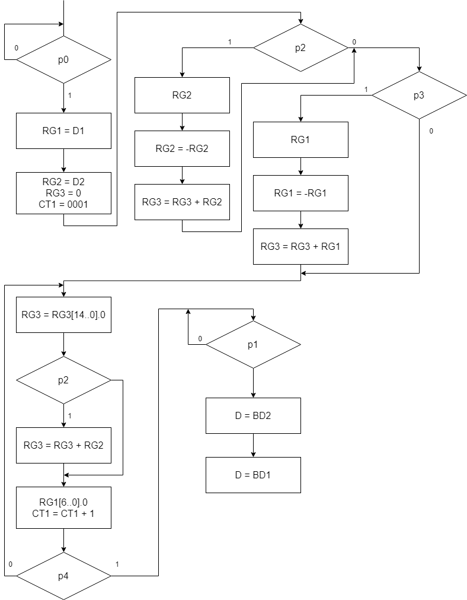

|  |  |  |  |  |  |  |  |  |  |  |  |  |  |  |
| --- | --- | --- | --- | --- | --- | --- | --- | --- | --- | --- | --- | --- | --- | --- |
|  | 13 | 12 | 11 | 10 | 9 | 8 | 7 | 6 | 5 | 4 | 3 | 2 | 1 | 0 |
| 1 | 0 | 0 | 0 | 0 | 0 | 0 | 0 | 0 | 0 | 0 | 0 | 0 | 0 | 1 |
| 2 | 0 | 0 | 0 | 0 | 0 | 0 | 0 | 0 | 0 | 0 | 0 | 1 | 0 | 0 |
| 3 | 0 | 0 | 0 | 0 | 1 | 0 | 0 | 0 | 1 | 1 | 0 | 0 | 0 | 0 |
| 4 | 0 | 0 | 1 | 0 | 0 | 1 | 0 | 1 | 0 | 0 | 0 | 0 | 0 | 0 |
| 5 | 0 | 0 | 1 | 0 | 0 | 0 | 0 | 1 | 0 | 0 | 0 | 0 | 0 | 0 |
| 6 | 0 | 0 | 0 | 0 | 0 | 0 | 0 | 1 | 0 | 0 | 0 | 0 | 0 | 0 |
| 7 | 0 | 0 | 0 | 0 | 0 | 0 | 1 | 0 | 0 | 0 | 0 | 0 | 0 | 0 |
| 8 | 0 | 0 | 0 | 1 | 0 | 0 | 0 | 0 | 0 | 0 | 1 | 0 | 0 | 0 |
| 9 | 0 | 0 | 0 | 0 | 0 | 0 | 0 | 0 | 0 | 0 | 0 | 0 | 1 | 0 |
| 10 | 1 | 0 | 0 | 0 | 0 | 0 | 0 | 0 | 0 | 0 | 0 | 0 | 0 | 0 |
| 11 | 0 | 1 | 0 | 0 | 0 | 0 | 0 | 0 | 0 | 0 | 0 | 0 | 0 | 0 |

|  |  |
| --- | --- |
|  | Код в 16 СС |
| 1 | 0001 |
| 2 | 0004 |
| 3 | 0230 |
| 4 | 0940 |
| 5 | 0840 |
| 6 | 0040 |
| 7 | 0080 |
| 8 | 0408 |
| 9 | 0002 |
| 10 | 2000 |
| 11 | 1000 |

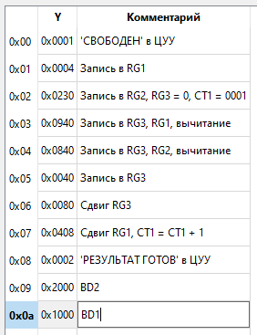

***4 способ в ДК с РК:***

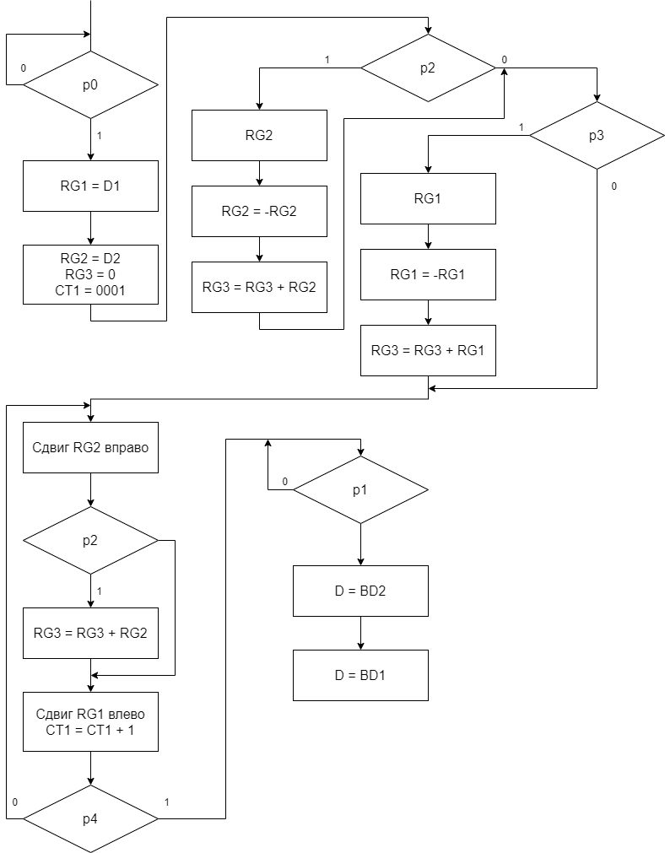

|  |  |  |  |  |  |  |  |  |  |  |  |  |  |  |
| --- | --- | --- | --- | --- | --- | --- | --- | --- | --- | --- | --- | --- | --- | --- |
|  | 13 | 12 | 11 | 10 | 9 | 8 | 7 | 6 | 5 | 4 | 3 | 2 | 1 | 0 |
| 1 | 0 | 0 | 0 | 0 | 0 | 0 | 0 | 0 | 0 | 0 | 0 | 0 | 0 | 1 |
| 2 | 0 | 0 | 0 | 0 | 0 | 0 | 0 | 0 | 0 | 0 | 0 | 1 | 0 | 0 |
| 3 | 0 | 0 | 0 | 0 | 1 | 0 | 0 | 1 | 0 | 1 | 0 | 0 | 0 | 0 |
| 4 | 0 | 0 | 1 | 0 | 0 | 1 | 1 | 0 | 0 | 0 | 0 | 0 | 0 | 0 |
| 5 | 0 | 0 | 1 | 0 | 0 | 0 | 1 | 0 | 0 | 0 | 0 | 0 | 0 | 0 |
| 6 | 0 | 0 | 0 | 0 | 0 | 0 | 0 | 0 | 1 | 0 | 0 | 0 | 0 | 0 |
| 7 | 0 | 0 | 0 | 0 | 0 | 0 | 1 | 0 | 0 | 0 | 0 | 0 | 0 | 0 |
| 8 | 0 | 0 | 0 | 1 | 0 | 0 | 0 | 0 | 0 | 0 | 1 | 0 | 0 | 0 |
| 9 | 0 | 0 | 0 | 0 | 0 | 0 | 0 | 0 | 0 | 0 | 0 | 0 | 1 | 0 |
| 10 | 1 | 0 | 0 | 0 | 0 | 0 | 0 | 0 | 0 | 0 | 0 | 0 | 0 | 0 |
| 11 | 0 | 1 | 0 | 0 | 0 | 0 | 0 | 0 | 0 | 0 | 0 | 0 | 0 | 0 |

|  |  |
| --- | --- |
|  | Код в 16 СС |
| 1 | 0001 |
| 2 | 0004 |
| 3 | 0250 |
| 4 | 0980 |
| 5 | 0880 |
| 6 | 0020 |
| 7 | 0080 |
| 8 | 0408 |
| 9 | 0002 |
| 10 | 2000 |
| 11 | 1000 |

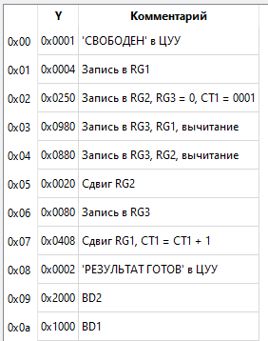

***Вывод:***

В ходе лабораторной работы были проработаны 4 способа умножения в прямом коде, в дополнительном коде с автоматической коррекцией и в дополнительном коде с ручной коррекцией. Также были созданы микропрограммы для проверки алгоритмов умножения разными способами. Было выявлено, что алгоритмы умножения схожи и отличаются лишь деталями.